2.37: a)
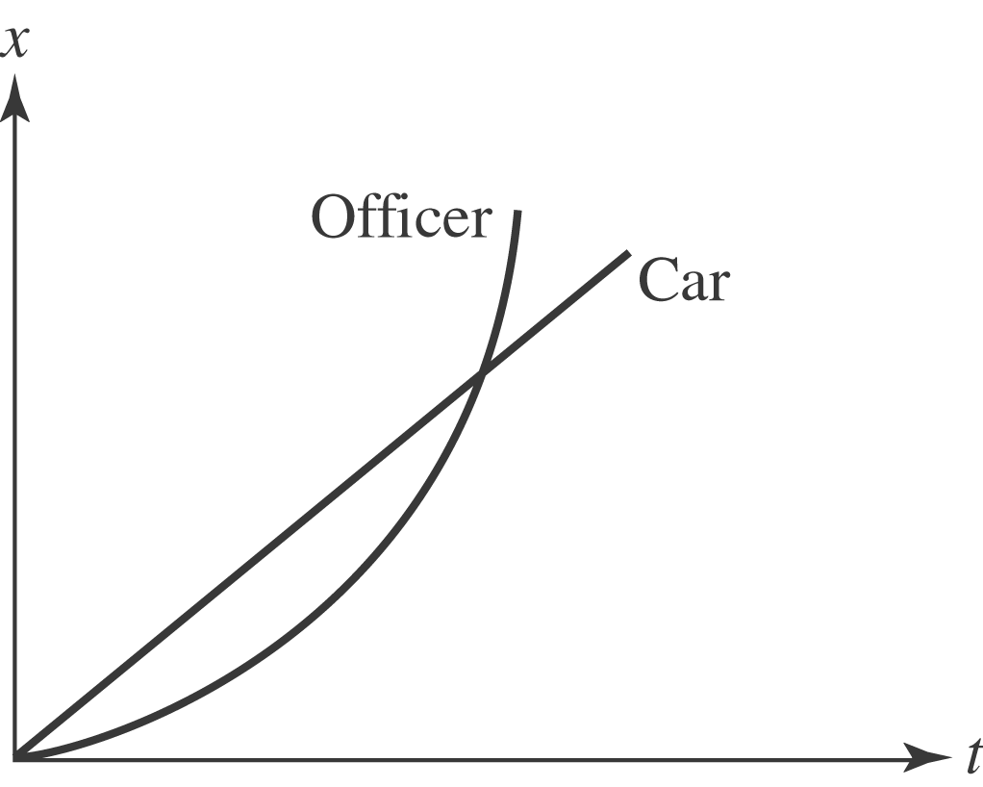

The car and the motorcycle have gone the same distance during the same time, so their average speeds are the same. The car's average speed is its constant speed v_{C}, and for constant acceleration from rest, the motorcycle's speed is always twice its
average, or 2v_{C}. b) From the above, the motorcyle's speed will be v_{C} after half the time needed to catch the car. For motion from rest with constant acceleration, the distance traveled is proportional to the square of the time, so for half the time
one-fourth of the total distance has been covered, or 